A-level Computer Science

Computer Science Introduction

Welcome to A-Level Computer Science where you will learn the next stages towards each topic of Computer Science. You will recognise some similar content for those of you that did GCSE Computer Science. We will re-cover some of this and then add to your knowledge with a little extra content. The course is split between two papers (one on screen) and you can find the outline of the content below. This will inevitably help you towards studying Computer Science at university where you can choose a specific route i.e Software Engineer, Networks, Data Management, Cyber Security, Machine Learning and more. If university is not for you, you could take on an apprenticeship scheme with a lot of companies. Some careers in Computer Science can be found by following the links at the end of this document. You can also do some extra independent research to find other potential roles.

Course Outline
- 10 Fundamentals of programming
- 11 Fundamentals of data structures
- 12 Fundamentals of algorithms
- 13 Theory of computation
- 14 Fundamentals of data representation
- 15 Fundamentals of computer systems
- 16 Fundamentals of computer organisation and architecture
- 17 Consequences of uses of computing
- 18 Fundamentals of communication and networking
- 19 Fundamentals of databases
- 20 Big Data
- 21 Fundamentals of functional programming
- 22 Systematic approach to problem solving
- 23 Non-exam assessment - the computing practical project

Assessments
Paper 1
What's assessed: this paper tests a student's ability to program, as well as their theoretical knowledge of Computer Science from subject content 10-13 above and the skills required from section 22 above.
Assessed
- On-screen exam: 2 hours 30 minutes
- 40% of A-level
Questions
Students answer a series of short questions and write/adapt/extend programs in an Electronic Answer Document provided by us.
We will issue Preliminary Material, a Skeleton Program (available in each of the Programming Languages) and, where appropriate, test data, for use in the exam.
Paper 2
What's assessed: this paper tests a student's ability to answer questions from subject content 14-21 above.
Assessed
- Written exam: 2 hours 30 minutes
- 40% of A-level
Questions
Compulsory short-answer and extended-answer questions.
Non-exam assessment
What's assessed: the non-exam assessment assesses student's ability to use the knowledge and skills gained through the course to solve or investigate a practical problem. Students will be expected to follow a systematic approach to problem solving, as shown in section 22 above.
Assessed
- 75 marks
- 20% of A-level

Transition Tasks

Create a separate word document titled “A-Level Computer Science Transition Tasks” to complete the following tasks in:

Task 1: Go to W3Schools and begin by choosing Python tutorials. Work your way through the different tutorials until you feel ready to take the Python exercises; these can be found under the Exercises tab at the top of the page. Screenshot your result and paste this into your transition word document.

Task 2: Now that you are familiar with Python, it is time to apply it to an activity. Choose either the easy or hard task below, completing the task in Python and screenshotting your code into your Word document.
Easy: Produce a program that will allow the user to input a number, and the program will then output the Fibonacci sequence up to that value. For example, if I enter the number 8, the program would output: 0, 1, 1, 2, 3, 5, 8, 13. If you have not heard of the Fibonacci sequence before, simply add the last two values in the sequence to get the next one.
Hard: Produce a program that generates four random numbers from 0-9, and then requires the user to guess the four digit combination. The user should be given a limited number of guesses, say 7, to guess the correct combination. Each time, the user guesses a number correctly, they should be shown that number. For example, the program would generate four random numbers shown as ****. I may then enter the guess 1 2 3 4. If three is in the sequence and in the correct space, then the program would now display **3*. If I then enter 7 5 3 2 and 7 is in the sequence but in the wrong place, then the program would still only display **3*.

Task 3: Watch the short video on 10 emerging technologies of 2019 from one year ago
(available at https://www.youtube.com/watch?v=hUsDdbqr0c8 ). In the video they describe 10 technologies that they believe were due a breakthrough in 2019.

- Of those 10 technologies, which do you believe holds the most potential?
- Which technology could be used to better humanity?
- Which of the 10 technologies is the most concerning to you, and why?

Write 200-500 words explaining your choices based on any research you choose to undertake online. Utilise skills gained from English to form a structured argument in your Word document, using good SPAG (spelling, punctuation and grammar) and paragraphs to answer the above questions.
Task 4: Copy the table below into your transition document and convert each of the given values between decimal, binary and hex. Then, add 0100 1000 to the binary value and convert the result of this summation into decimal.

Decimal | Binary  (8 bits) | Hex | Add 0100 1000 to the binary value | New Decimal Number
1
 | 0001 0110
 |  | 2B
 | 0101 1110
248
 |  | FF

Task 5: Answer the following questions, showing all of your workings.
1. A bitmap graphic has an image size of 50 × 50 pixels. It uses four colours: white, black, yellow and blue.
Calculate the minimum amount of storage space that is required to store the bitmap image, excluding metadata. Express your answer in bytes.
Answer:

2. A sound has been sampled and recorded. The sound was sampled for 1 minute and 40 seconds at a sample rate of 8000 Hz with a 16-bit sample resolution.
Calculate the minimum amount of storage space, in megabytes, needed to store the sampled sound.
Answer:

Task 6: Copy into your transition document and complete the truth tables for the expressions.

A AND B
A | B | A AND B

A OR B
A | B | A OR B

NOT(A OR B)
A | B | NOT(A OR B)

Career Links within Computer Science

Some jobs you can get with a Computer Science Qualification:
`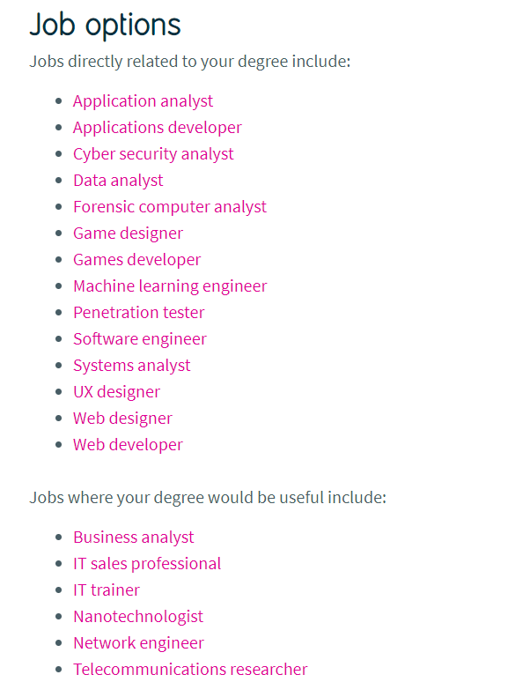
Visit the link below to view these job roles in more detail:
What can I do with a computer science degree? | Prospects.ac.uk

University Courses within Computer Science
View website below to see what you can do in university with a Computer Science qualification (You can also research other universities):
BSc (Hons) Computing (with Foundation Year option) | Bournemouth University

Apprenticeships within Computer Science

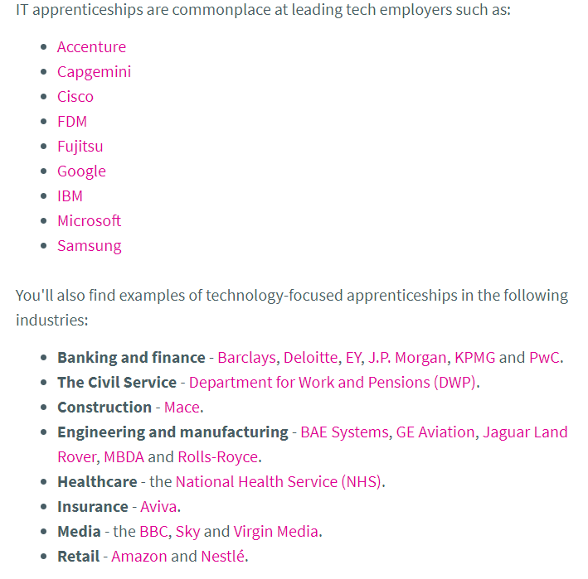
You can visit the link below to view these apprenticeships in more detail:
IT apprenticeships | Prospects.ac.uk

You can find lots more information by visiting the link below:
My Learning My Future: Computer Science/IT | CEC Resource Directory (careersandenterprise.co.uk)

